

**Project Report**

***Fan O Fan***



**Group Members**

* **Muhammad Hammad Yousuf**
* **Prisicla Farhan**
* **Amna Ramzan**

Contents

**1. Definition of the Problem ..........................................................3**

**2. Requirement Analysis** **................................................................3**

**3. Design Phase .................................................................................4**

**4. Source Code ...................................................................................5**

**5. User Guide .....................................................................................10**

**1. Definition of the Problem**

FANoFAN Company is into manufacturing and selling on Fans. They manufacture fans for various needs of customers. From Ceiling Fans to Table Fans to Exhaust Fans, they are into all types of Fan Manufacturing.

They are looking to come up with their own website and display all the products available with them. They want to provide a detailed information about all their products.

**2. Requirement Analysis**

The Web site is to be created based on the following requirements.

1. The Home Page should be created making use of Sections with a suitable logo, the header section can be added which will show images Fans.
2. The site must contain the links to navigate through any category for the information.
3. Links of bottles can be categorized like (Ceiling Fans, Table Fans, Exhaust etc.)
4. Specification and Pricing of Fans can be added along with the images.
5. Gallery section can be added for viewing different images.
6. Feedback must be allowed to enter by the viewer
7. Site map, Gallery, about us, Queries link, Contact us link must be added.
8. The complete description must be allowed to get download as pdf or doc file.
9. The advertise section with various facilities provided should be mentioned.

**3. Design Phase**

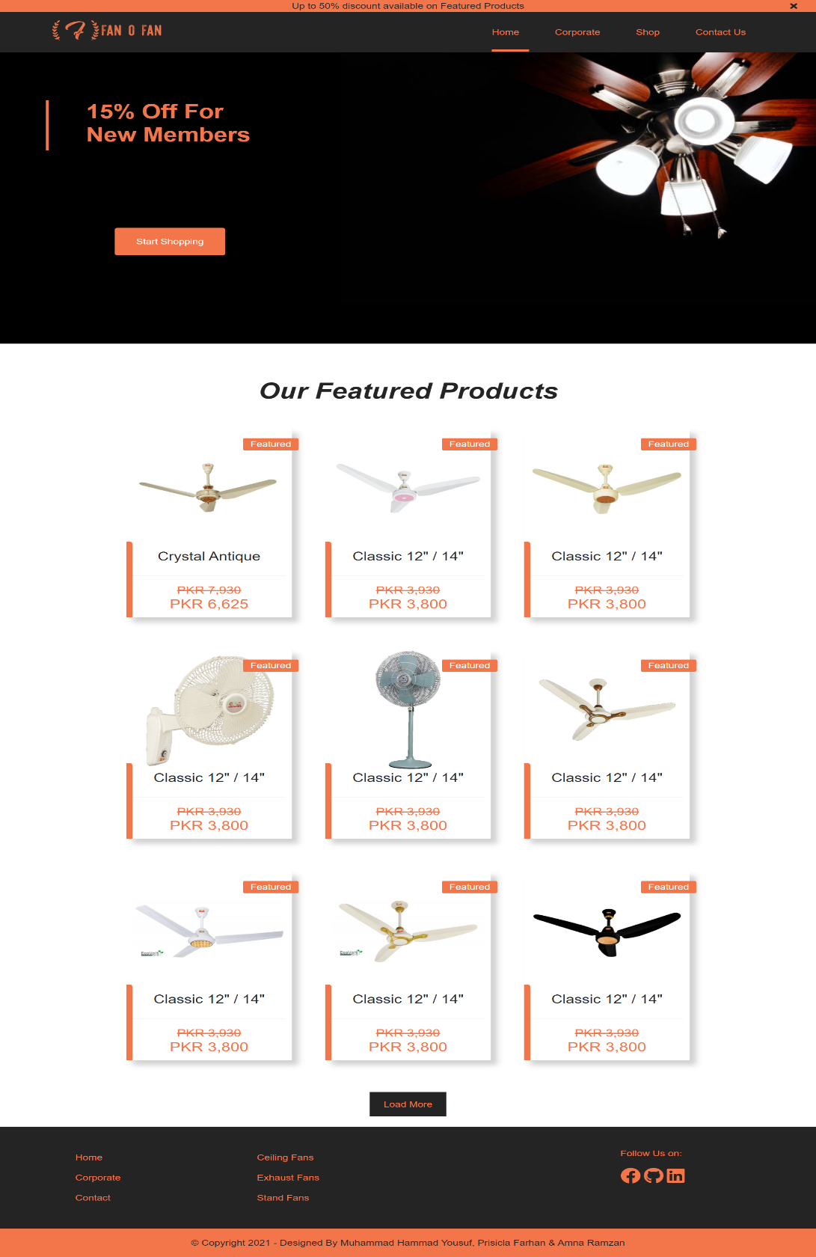

**4. Source Code**

**Home Page**

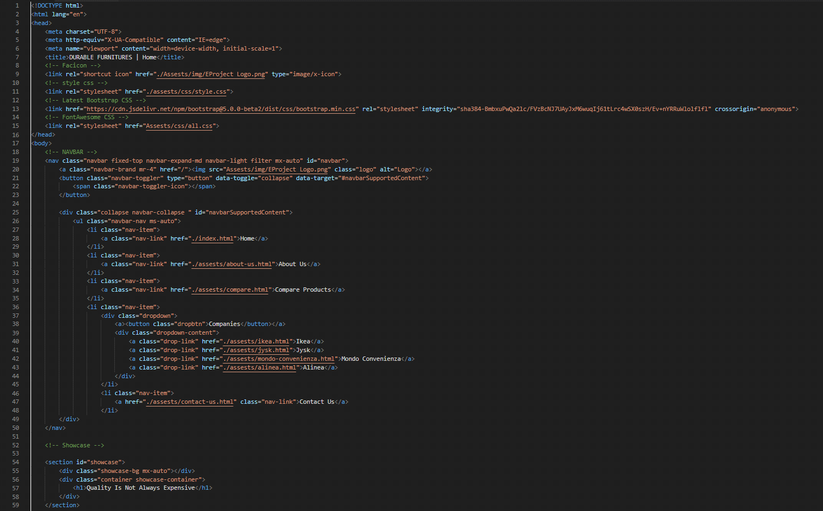

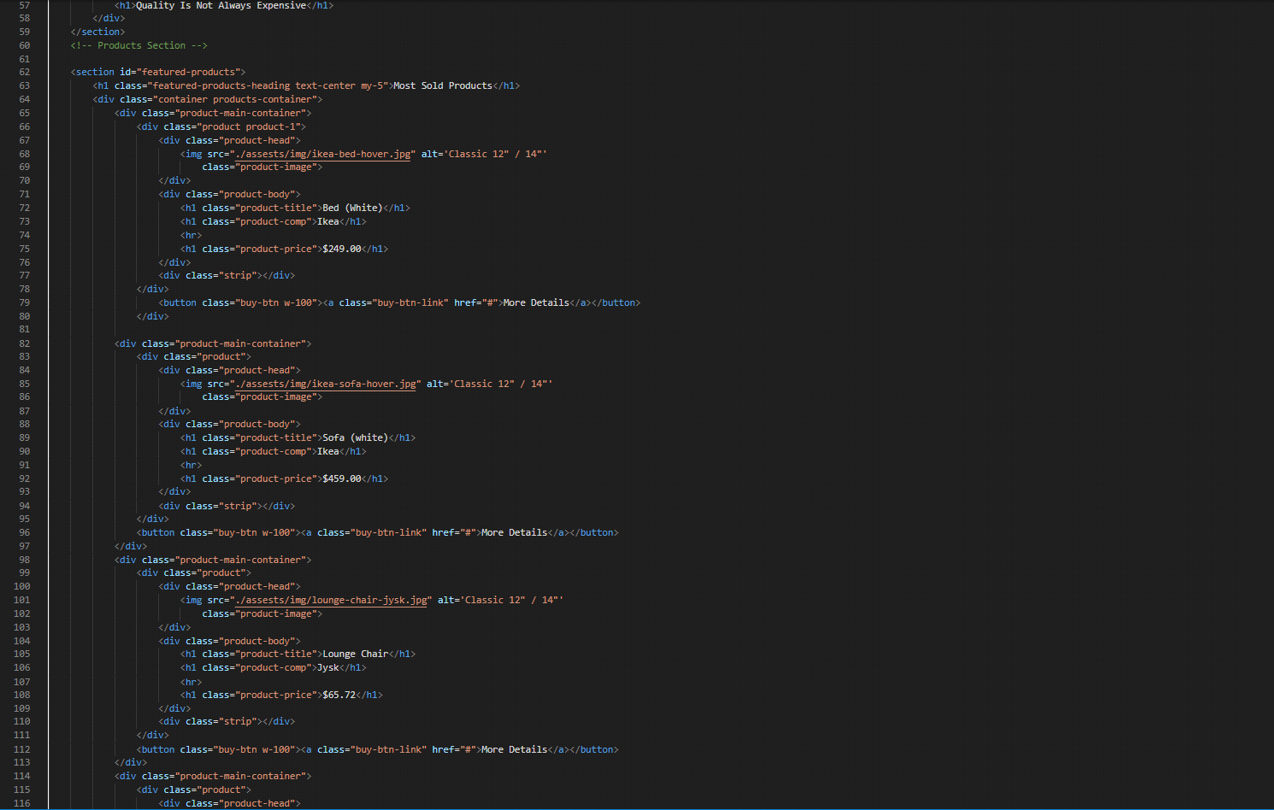

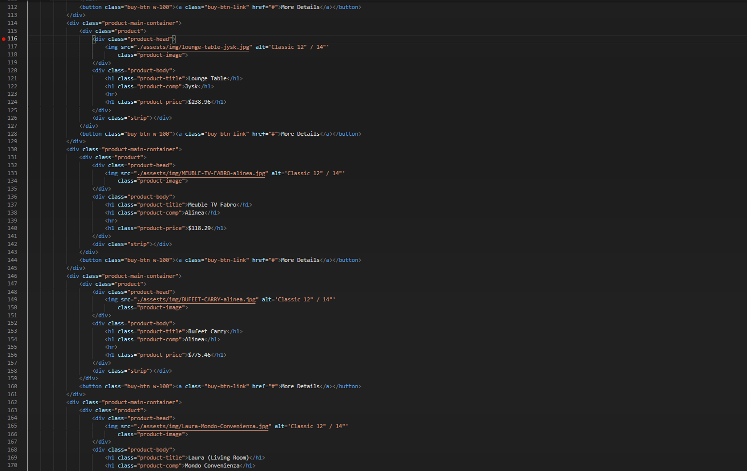

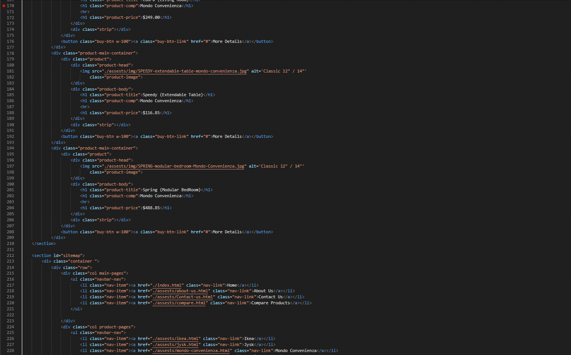

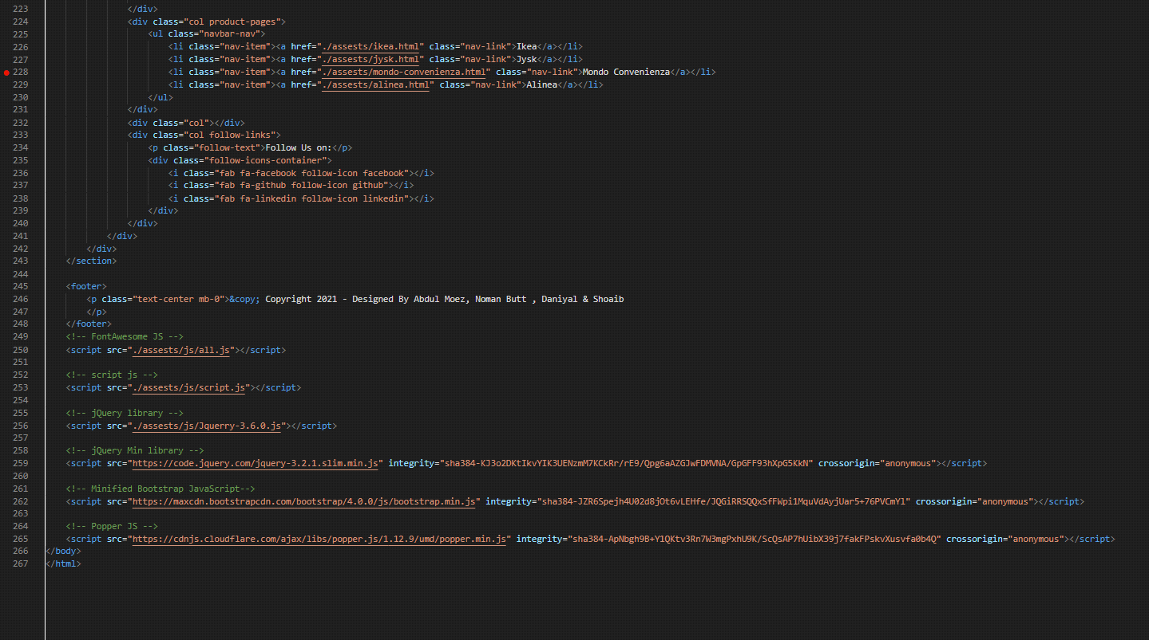

**About Us Page**

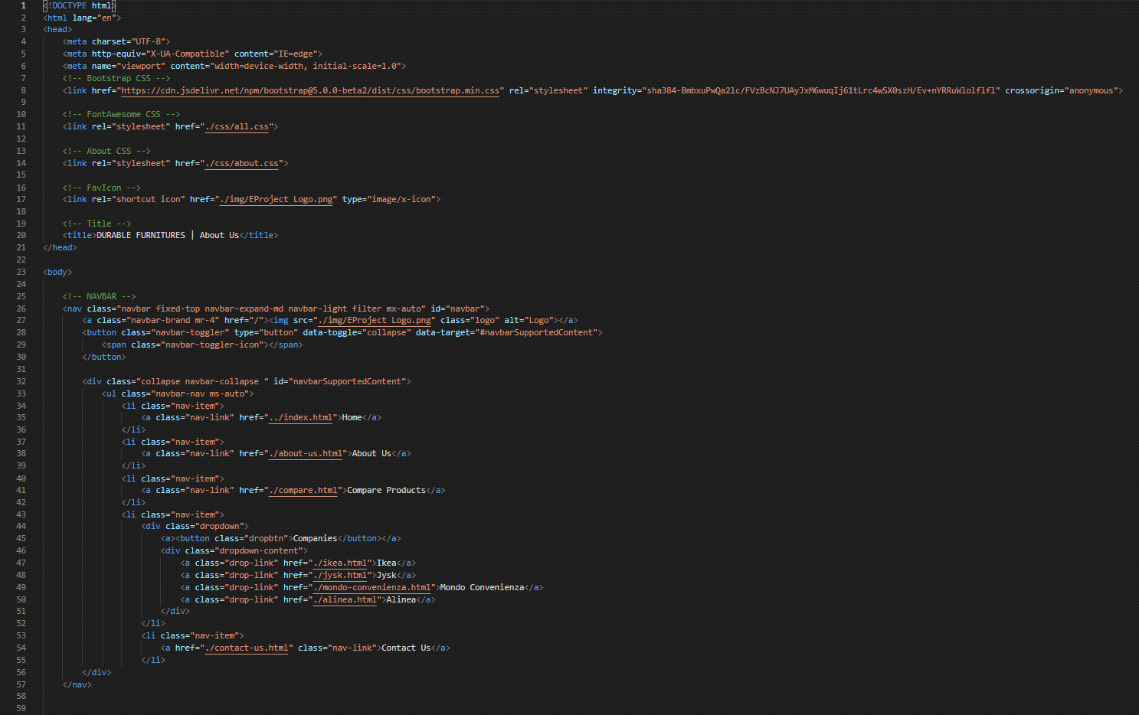

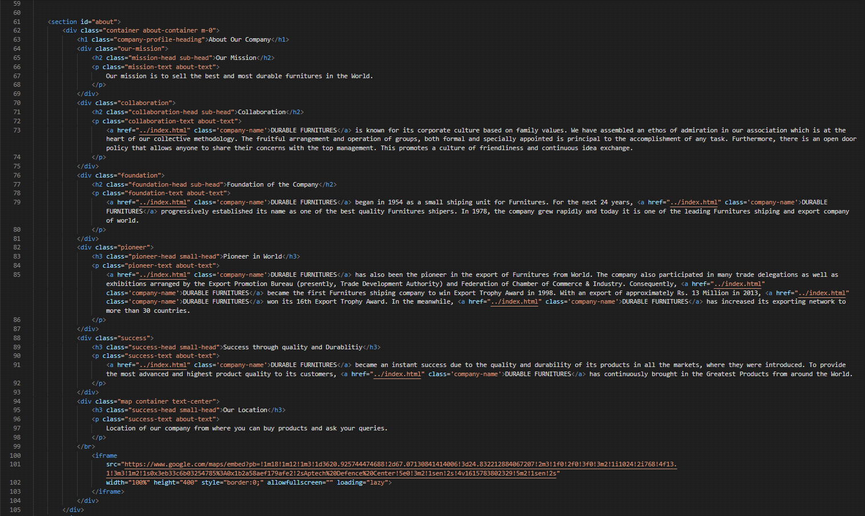

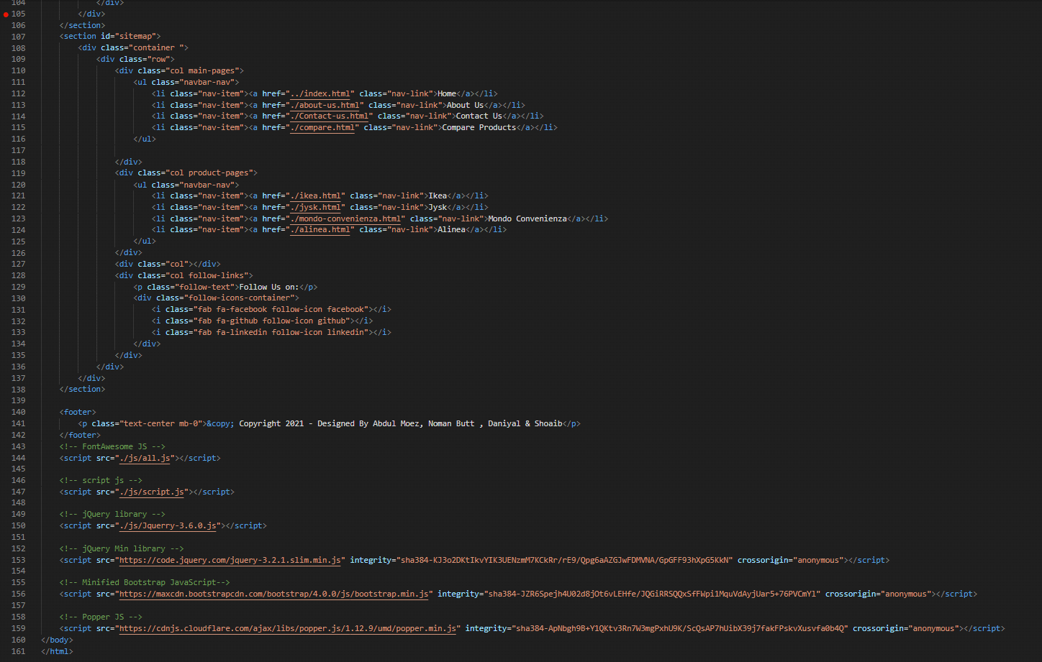

**5. User Guide**

FANoFAN Company is into manufacturing and selling on Fans. They manufacture fans for various needs of customers. From Ceiling Fans to Table Fans to Exhaust Fans, they are into all types of Fan Manufacturing.

They are looking to come up with their own website and display all the products available with them. They want to provide a detailed information about all their products.

**Requirement Specification:**

The Web site is to be created based on the following requirements.

* The Home Page should be created making use of Sections with a suitable logo, the header section can be added which will show images Fans.
* The site must contain the links to navigate through any category for the information.
* Links of bottles can be categorized like (Ceiling Fans, Table Fans, Exhaust etc.)
* Specification and Pricing of Fans can be added along with the images.
* Gallery section can be added for viewing different images.
* Feedback must be allowed to enter by the viewer
* Site map, Gallery, about us, Queries link, Contact us link must be added.
* The complete description must be allowed to get download as pdf or doc file.
* The advertise section with various facilities provided should be mentioned.

**THANK YOU**